

**Acknowledgement**   
We are quite grateful for the instruction offered by our distinguished Teacher. Rajan Raj Pant, for his guidance and assistance with our networking group project. His skills and encouragement helped us navigate network design and setup challenges. We would also want to thank Asia Pacific University (APU) and its LBEF teachers for providing us with the materials and a suitable learning atmosphere that enabled us to complete this project. We are grateful for the collaboration and teamwork that allowed us to complete this project. We worked together to establish a complete network architecture for Sun System and Consultants' new development and support center in Melbourne. Thank you to everyone who made the project a success.

- Thank You

Table of Content  
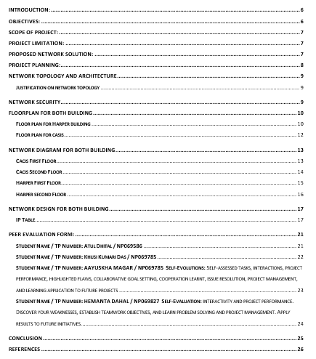

# Introduction:

As Sun System & Consultants develops in Melbourne by establishing a new development and support center, the requirement for a robust and efficient network becomes increasingly crucial.  
With a thorough understanding of the company's goals and priorities, our team was tasked with suggesting the best network design to facilitate communication, collaboration, and seamless data sharing between departments and buildings. The aim of this design is to specify the features and characteristics needed to establish a communications system that satisfies the new centers' requirements while maintaining flexibility, security, and optimal performance. Using cutting-edge technology and industry best practices, we want to build an interactive environment that meets the different demands of teams ranging from development to testing to professional sales (fcit.usf.edu/, n.d.).

# Objectives:

The main aims of this project was to provide well function working network for Sun System & Consultants.

1. Promote cross-departmental cooperation through efficient and transparent network design.
2. Develop a network design to support future infrastructure and workforce development.
3. Improve overall system performance by ensuring reliable and fast connections.
4. Implement security measures like as firewalls, backups, and endpoint security to prevent attacks and maintain data integrity.
5. Create simple network setups for easy maintenance and troubleshooting.
6. Securely connect Harper and Cacis buildings using at least 100 Mbps of bandwidth.
7. VoIP phones and network printers can help departments communicate more efficiently.
8. Implement strong security measures, including firewalls and endpoint protection.

# Scope of project:

The project scope includes building the network infrastructure for Sun System & Consultants' new Melbourne development and support center. Main Scope of Project are following:

1. Create a department-neutral IP addressing system to ensure optimal network communication.
2. Determine bandwidth needs and recommend the best internet service provider.
3. Configure network gear, such as routers, switches, and access points, for optimal performance and security.
4. Use firewall software to monitor network traffic, both incoming and outgoing.
5. Look for affordable choices that don't sacrifice security or performance.

# Project limitation:

Sun System & Consultants' new Melbourne development and support center provides a comprehensive and efficient network design, however there are certain limitations to consider.   
Following are the main Limitation for This Project are following:

1. Limited budget may make purchasing high-quality network hardware and security solutions problematic.
2. Due to the project's short timeline, extensive testing and validation may not be feasible.
3. There may be a shortage of experienced managers and implementers.
4. The building's structure might impede equipment installation and placement.
5. Even with preparedness, new threats and vulnerabilities may arise.
6. Unexpected changes to tactics and methodologies may affect long-term validity.

# Proposed network solution:

The scenario describes a hierarchical network design with three layers:

1. Core layer: High-speed fiber connections between buildings to ensure dependable data transfer.
2. Distribution Layer: Each building has controlled switches that efficiently distribute traffic.
3. Access Layer: PoE-enabled switches and access points that provide wired and wireless user access.

# Project planning:

Sun Systems & Consultants' implementation of the suggested network architecture will guarantee a secure, scalable, and user-friendly network for the new Melbourne Centre. This foundation promotes the company's growth and collaboration objectives while also creating a productive and inventive work environment.  
Record and transmit entire documentation, including network diagrams, configurations, and security rules, after deliverables have been completed. **Gantt chart**

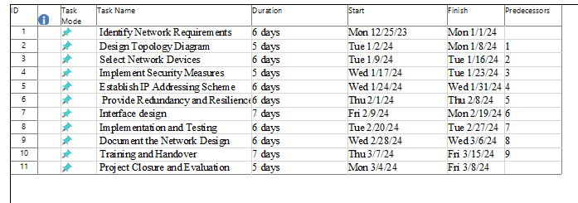

**Project Timeline**  
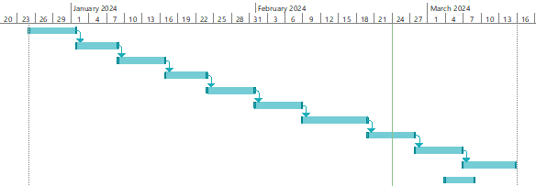

# Network Topology and Architecture

An alternate term for a network architecture diagram is a network infrastructure diagram, which helps managers visualize their whole network infrastructure and architecture. It provides a comprehensive picture of the network layers and resources by encompassing hardware, software, wireless connections, protocols, layout and topology.

## **Justification on network topology**

There is different kinds of network topology such as Ring network topology.   
**Mesh network topology:** A bus network architecture consists of a single flat network in which all devices, known as stations, physically link and transfer data to one another (techtarget, 2022).

**Star network topology**: A star topology, also known as a hub-and-spoke topology, relies on a central node, which is often a router or a Layer 2 or Layer 3 switch (techtarget, 2022).

**Tree network topology:** A tree topology is a hierarchical structure in which nodes connect and arrange themselves like a tree when depicted in network diagram form. Network experts usually implement tree topologies with core, distribution, and access layers (techtarget, 2022).

**Hybrid network topology:** Corporate networks frequently utilize many types of network topology. One topology may be better to another based on considerations like as performance, reliability, and cost (techtarget, 2022).

The Sun System and Consultants Company uses Star topology as its network topology in each of its two buildings' departments. When hubs, switches, and routers are physically connected to each other, the network design is known as a star topology. In a star topology, a central hub serves as a server, and the nodes that connect it serve as clients.

# Network Security

Protecting networks and data from threats like hacking and intrusions is the responsibility of network security. We offer a wide range of well-designed network security solutions, including firewalls, network analytics, application security, virus and antivirus software, access control, and more, to help businesses cut overhead costs and protect against costly losses caused by data breaches or other security incidents.

# Floorplan for Both Building

We Design a floor plan to clarify the network structure of the Project.

## **Floor plan for Harper building**

### First Floor Harper (NP069785/ Aayuskha Magar)

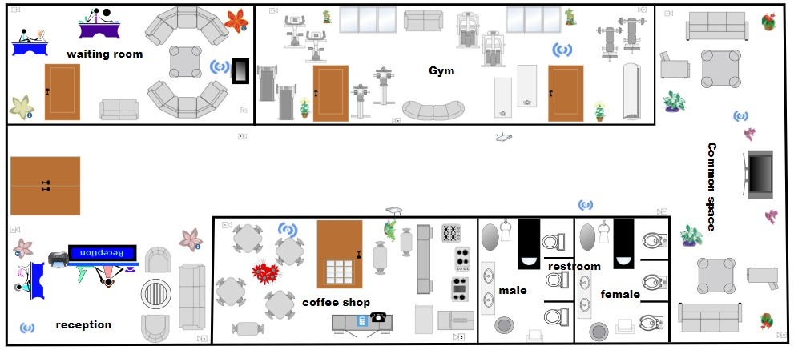

### Second Floor Harper (HEMANTA DAHAL / NP069827)

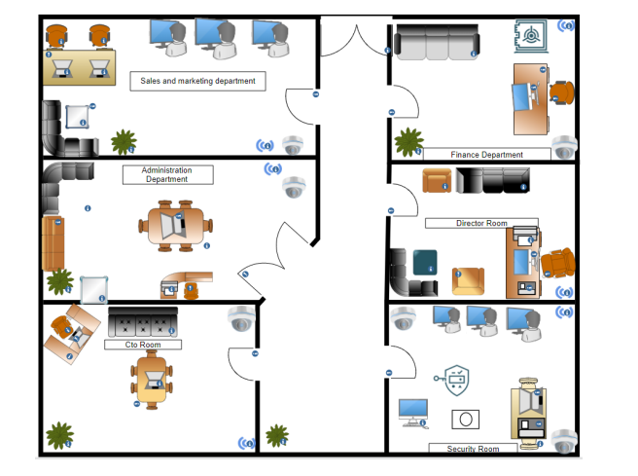

## **Floor plan for casis**

### First Floor Cacis(Khusi Kumari Das / NP069785)

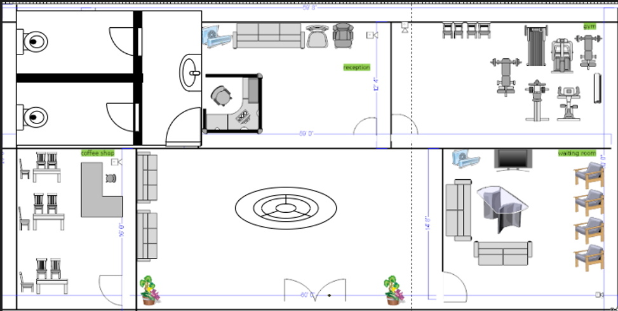

### Second Floor Casis(Atul Dhital / NP069586)



# Network Diagram for both Building

## **Cacis First Floor**

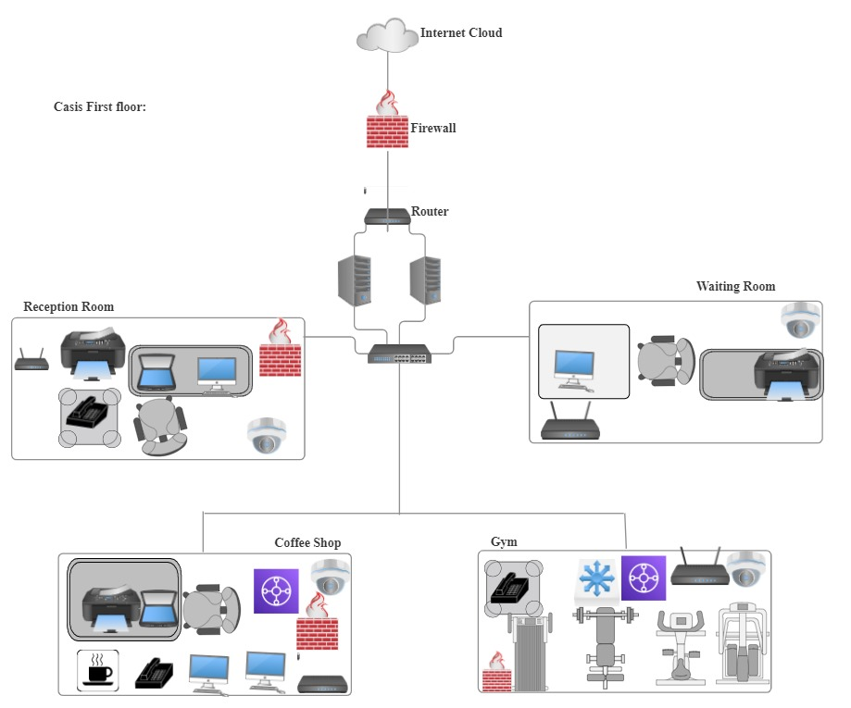

## **Cacis Second Floor**

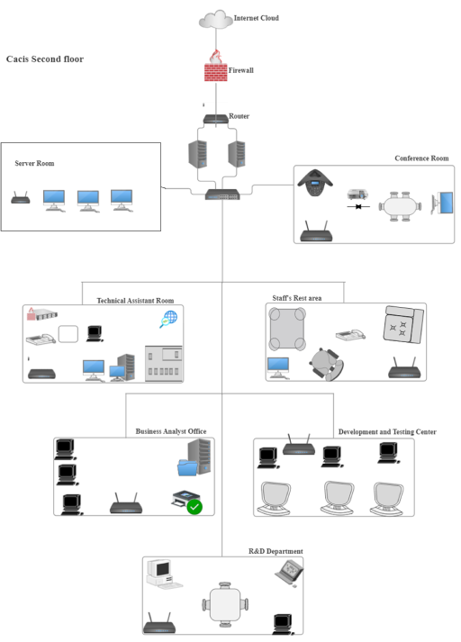

## **Harper First Floor**

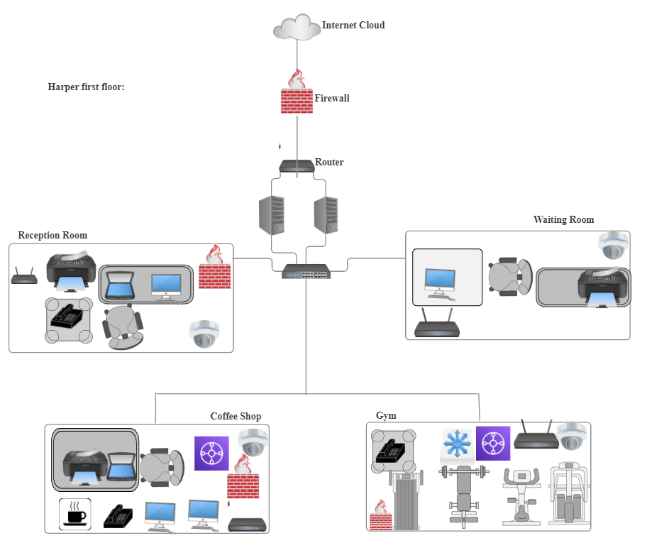

## **Harper second Floor**

# Network Design for both building

We Defined a specific IP address for each floor to make network smooth and work as per the requirement of the project and fulfill the Importance.  
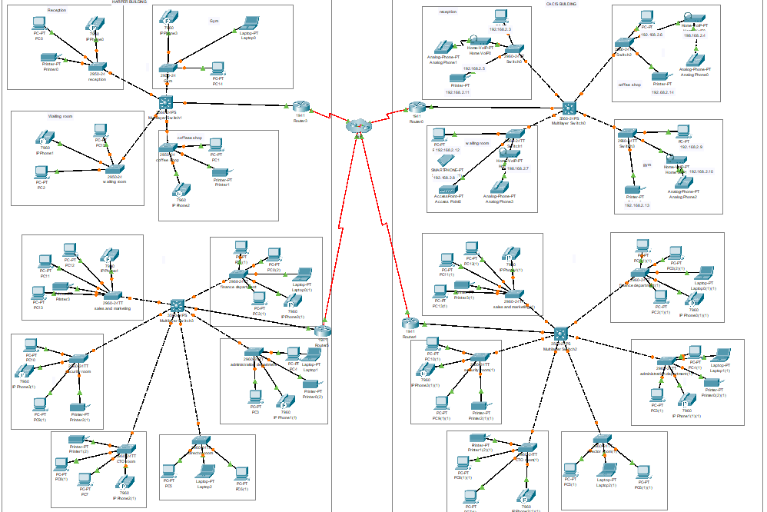

## **IP Table**

### Student Name / TP Number: Atul Dhital / NP069586

### Student Name / TP Number: Khusi Kumari Das / NP069785

I used the following Networks IP address for configure the casis first floor

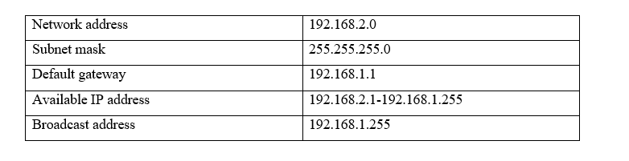  
Each room IP address and used devices

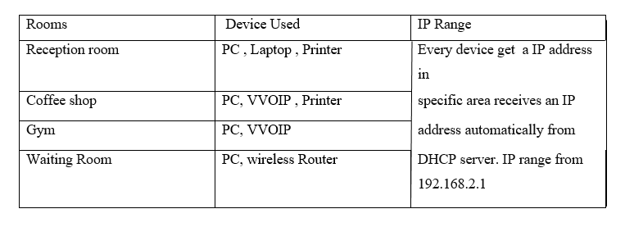

### Student Name / TP Number: Aayuskha Magar/ NP069847

I used the following Networks IP address for configure the Harper first floor

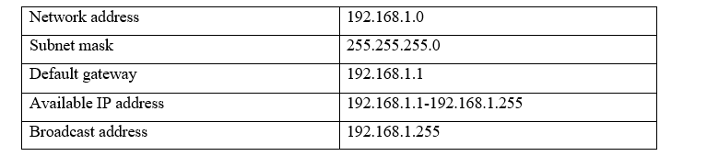  
Each room IP address and used devices

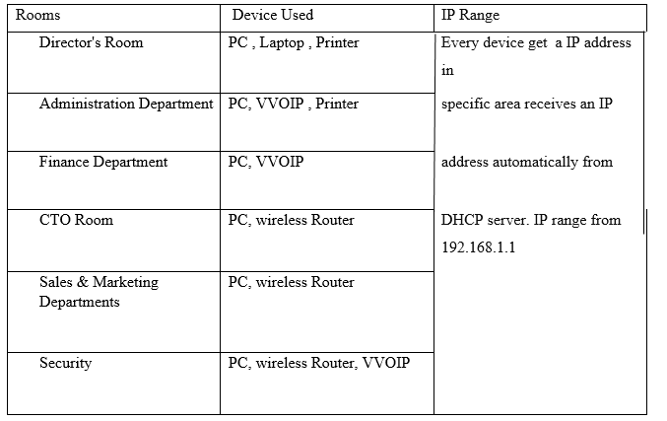

### Student Name / TP Number: Hemanta Dahal / NP069827

I used the following Networks IP address for configure the Harper first floor

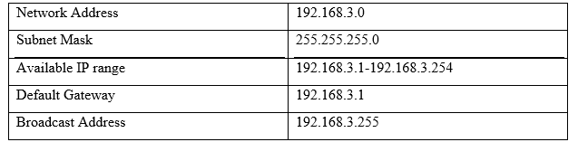  
Each room IP address and used devices

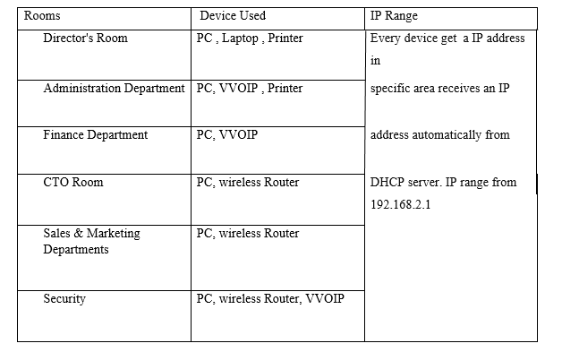

# Demonstration:

|  |  |  |
| --- | --- | --- |
| Test case: Internal building routing test | | Date:2/26/2024 |
| S.N. | Expected Output | Actual Output |
| 1 | Router of floor 1 with IP 192.168.1.1 should ping with pc1 of floor 2 of IP 192.168.3.11 in harper building. | Successfully router 1ping with pc1. |
|  | | |

|  |  |  |
| --- | --- | --- |
| 2 | Router0 of floor 1with IP 192.168.2.1 should ping with pc1 of IP 192.168.4.19 in cacis building. | Successfully floor1 ping with pc1. |
|  | | |
| Test case: External building routing test | | |
| S.N. | Expected Output | Actual Output |
| 1 | Pc1 of harper building first floor with IP 192.168.1.6 should ping with Pc1 of casic building first floor with IP 192.168.2.6. | Successfully Pc1 of harper ping with Pc1 0f casic. |
|  | | |
| 2 | Pc 1 of harper second floor with IP 192.168.3.11 should ping with Pc1 of casic second floor IP 192.168.4.19. | Successfully pc1 of harper ping with pc1 of casic. |
|  | | |

# Peer Evaluation Form:

We have Evaluate each group member according to their work in Group Assignment.

## **Student Name / TP Number: Atul Dhital / NP069586**

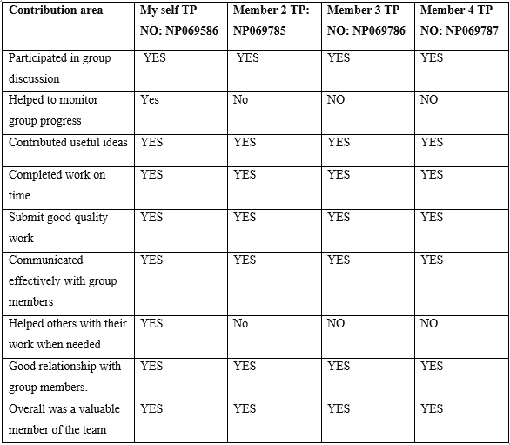

**Self-evaluation:** I assessed my duties, interactions, and project performance to see how effectively I contributed to a collaborative project. I recognized my weaknesses and established my next collaboration objectives. This allowed me to use my expertise and enhance my teamwork abilities. I learnt how to collaborate in groups to solve challenges and discover answers. Overall, the experience was I learned valuable project management and cooperation skills that I want to use in my future endeavors.

## **Student Name / TP Number: Khusi Kumari Das / NP069785**

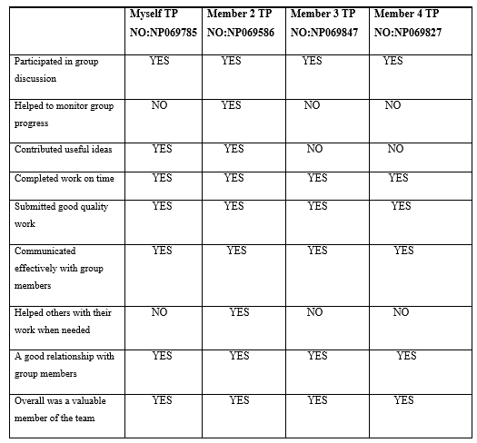

**Self-Evaluation:** Self-reflection to develop a complete network architecture adapted to the unique requirements of Sun Systems & Consultants' new site. We have tested the network infrastructure to assure its functioning and durability.

## **Student Name / TP Number: AAYUSKHA MAGAR / NP069785** **Self-Evolutions:** Self-assessed tasks, interactions, project performance, highlighted flaws, collaborative goal setting, cooperation learnt, issue resolution, project management, and learning application to future projects

## **Student Name / TP Number: HEMANTA DAHAL / NP069827** **Self-Evaluation:** Interactivity and project performance. Discover your weaknesses, establish teamwork objectives, and learn problem solving and project management. Apply results to future initiatives.

# Conclusion

In conclusion, our team successfully designed a network infrastructure for Sun System & Consultants' new Melbourne facility. Our solution warranted a highly-detailed physical layout, thorough choice of device, an IP address scheme with a thoughtful division at each layer of the OSI model and essential security measures. We effectively collaborated on the production of this thorough response to the project needs and each member delivered quality contributions reflective of the specific skills they were to acquire in the course.

# References

(n.d.). Retrieved from ico.org.uk: https://ico.org.uk/

(2023, jan 30). Retrieved from tutorialspoint: https://www.tutorialspoint.com/

(2024). Retrieved from techtarget: https://www.techtarget.com/searchnetworking/definition/network-topology

(2024). Retrieved from check point: https://www.checkpoint.com/cyber-hub/network-security/

fcit.usf.edu/. (n.d.). *fcit.usf.edu*. Retrieved from https://fcit.usf.edu/: https://fcit.usf.edu/network/chap1/chap1.htm